**2.1 I can review the on-going use of IT tools and techniques and change the approach as needed**

After I have finished each piece of written work, I check it using Grammarly. Below is a screenshot of one occasion that I did this, and as a result made a number of changes to my work.

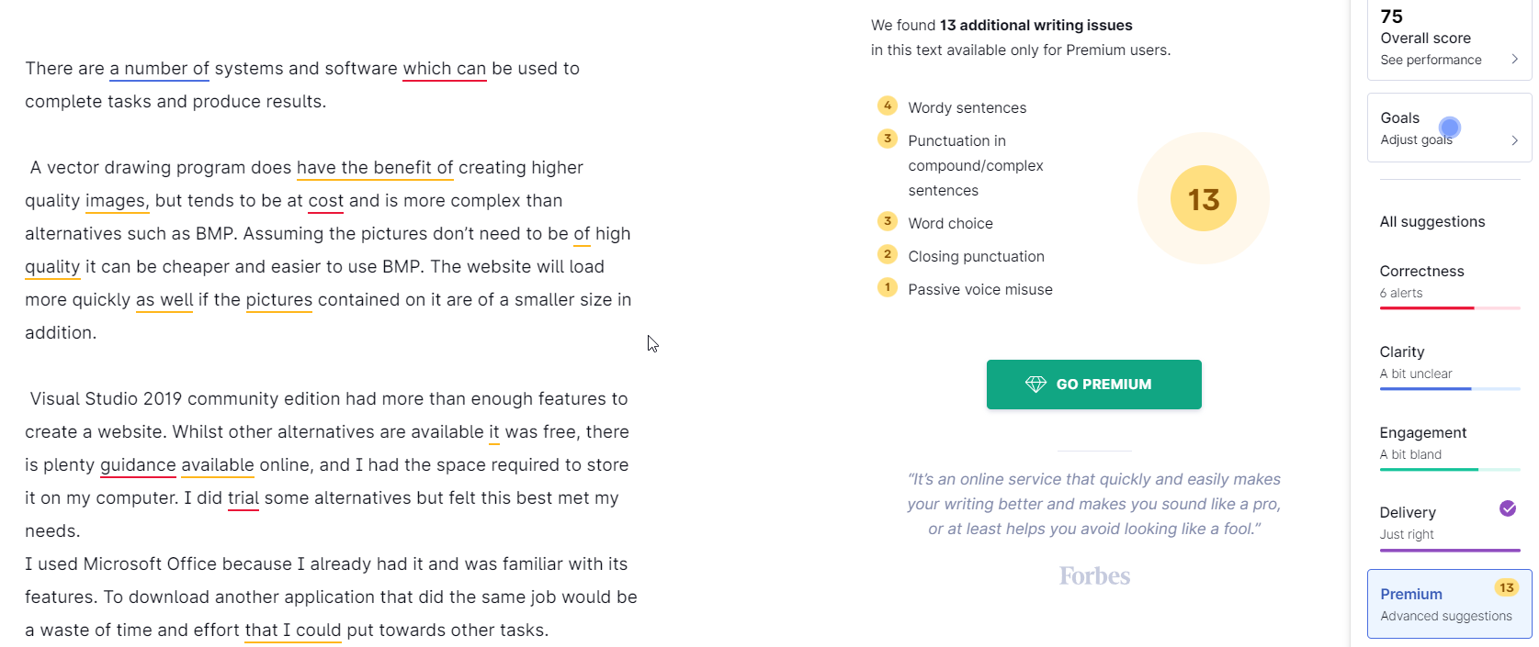

Fairly early on I also identified that I was having difficulty using my keyboard because of how far away my computer is and how relatively short the cable is. Because of this I started using a wireless keyboard which is much more convenient.

I also often find it helpful, and certainly did with this project, to see how my document will look in printed format. Here is a screenshot showing me doing this in Microsoft Office Word.

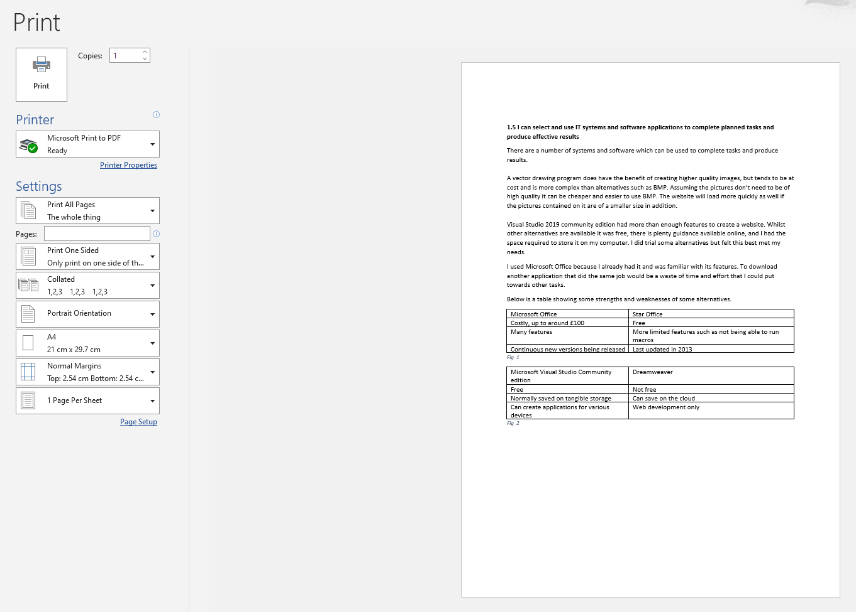

As a result of this I increased the size of the text slightly and added more spacing.